**SERVICE MANAGEMENT AS A PRACTICE**

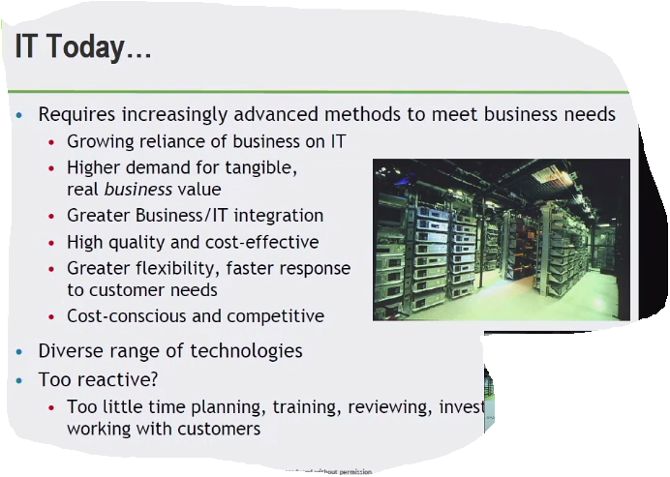

**IT Exists = Business**

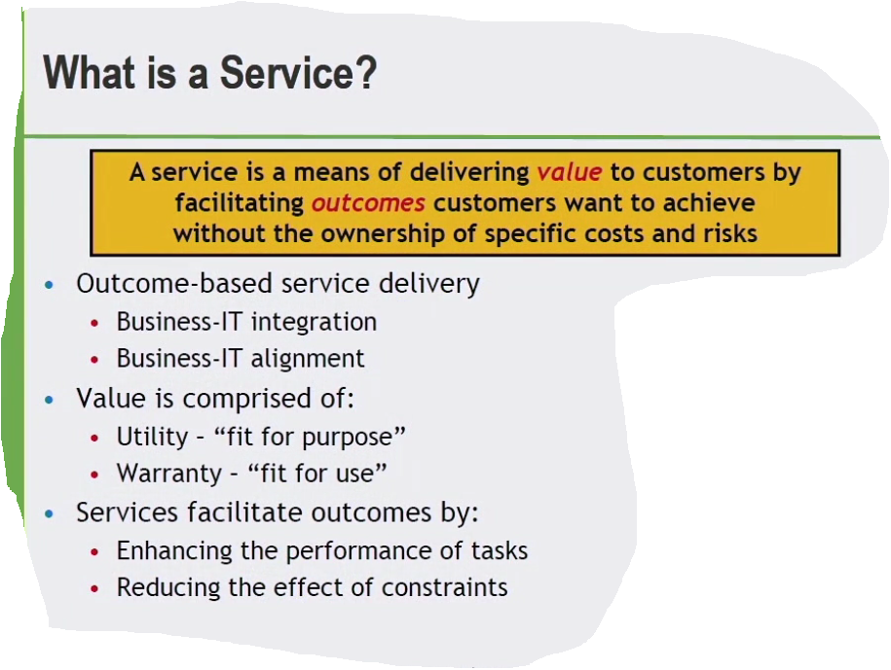

**Utility**

* **Service meets a particular need**

**Warranty**

* **Do we have enough capacity, security, what they get vs. how they get**

**A service provided to one or more customers by an IT Service Provider**

**Internal Service**

* **Departments or business units that support internal activities**

**External Service**

* **Service that achieves business outcomes**

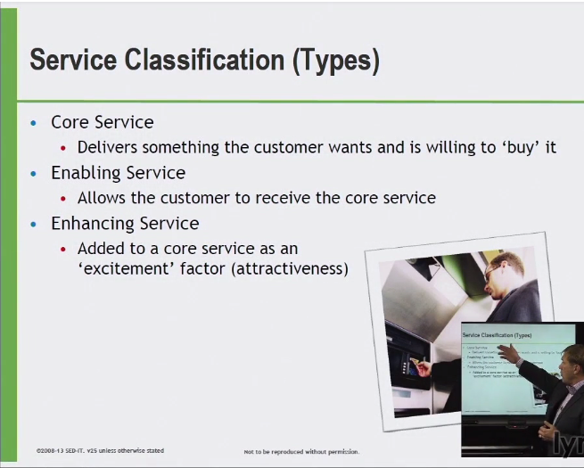

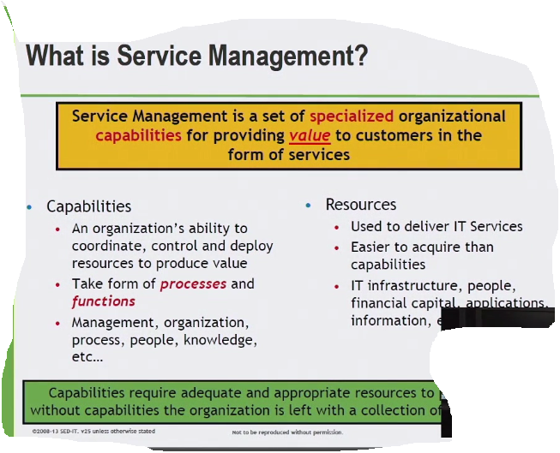

**DEMING MODEL**

**PLAN -> DO -> CHECK -> ACT**